Frank Dentener, European Commission, Joint Research Centre, Sustainable Resources Directorate

Date: 01.02.2018

Email: frank.dentener@ec.europa.eu
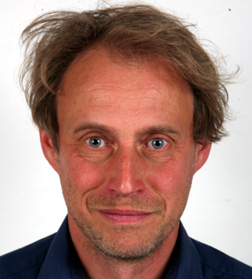

Frank Dentener works since 25 years in the field of atmospheric pollution, climate change and agriculture. Frank is senior expert at the European Commission’s Joint Research Centre. He completed a Ph.D. in Physics with Nobel prize-laureate Paul Crutzen. He is member of the scientific advisory board of the JPI FACCE, and co-chair of WMO’s Scientific Advisory Group on near-real-time applications. He has (co-) authored more than 200 peer-reviewed publications and 3 IPCC reports, H-factor 80, and is a Thomson-Reuters highly cited scientist. He is an expert in atmospheric chemistry-land interactions including ozone impacts on agriculture, agricultural production systems, and climate change and mitigation and adaptation. He has served on a variety of international commissions and task forces, and has supervised/examined ca. 10 Ph.D. and habilitation candidates.

